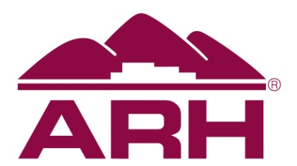
NEWS BRIEF

Contact Information:
Elaine Bailey
Corporate Communications Writer
Appalachian Regional Healthcare
606-269-1952 (Cell)
ebailey2@arh.org

Protect yourself against stroke

October 27, 2020, Lexington, Ky. – Did you know that every 40 seconds, someone has a stroke? Knowing the warning signs of a stroke may be the difference between recovery and disability. Learn to think and act F.A.S.T. (see chart).

Observed annually, World Stroke Day (on October 29) underscores the serious nature and high rates of stroke, raises awareness of the prevention and treatment of the condition and ensures better care and support for survivors.

According to the American Stroke Association, stroke affects about one in four people worldwide. It can happen to anyone at any age. The good news is that 80 percent of first strokes may be prevented.

“Prevention is key—one of the best things you can do is keep a close check on your blood pressure,” said Aman Deep, MD, ARH neurologist. “High blood pressure is a leading cause of stroke. If you are taking blood pressure medicine, make sure you take it regularly. It is important to keep your numbers below 120/80. If your numbers are consistently higher, make an appointment with your healthcare provider.”

Other stroke preventative measures include no smoking, eating a heart-healthy diet that includes colorful fruits and vegetables, getting seven to nine hours of quality sleep each night and staying physically active by taking walks or exercising.

“Quality sleep can improve brain function right away,” stated Deep. ‘Sleep-related breathing issues may increase stroke risk, so if you are having sleeping issues, consult with your healthcare provider. You may need to have an at-home sleep evaluation.”

According to Deep, staying active through exercise or leisure walks each week is important.
“Being physically active actually activates brain cells, which encourages them to grow and connect more efficiently,” he said.

The American Heart Association states that having diabetes more than doubles your risk of stroke. Every two minutes, an adult with diabetes in the U.S. is hospitalized for stroke. Work with your doctor to manage your diabetes and reduce your risk. Also, high cholesterol increases the risk of blocked arteries. If an artery leading to the brain becomes blocked or throws a clot, a stroke can occur.

“If you have diabetes or high blood cholesterol, work with your physician to get it under control,” said Dr. Deep. “There are several ways you can protect yourself against stroke. Don’t be that one in four!”

# # #

ARH is a not-for-profit health system operating 13 hospitals in Barbourville, Hazard, Harlan, Hyden, Martin, McDowell, Middlesboro, Prestonsburg, West Liberty, Whitesburg and South Williamson in Kentucky and Beckley and Hinton in West Virginia, as well as multi-specialty physician practices, home health agencies, home medical equipment stores and retail pharmacies. ARH employs more than 6,000 people with an annual payroll and benefits of $330 million generated into our local economies. ARH also has a network of more than 600 active and courtesy medical staff members. ARH is the largest provider of care and single largest employer in southeastern Kentucky and the third largest private employer in southern West Virginia.

